

Melville Senior High School

Semester Two Examination, 2020

Question/Answer booklet

MATHEMATICS

If required by your examination administrator, please place your student identification label in this box
METHODS
UNITS 1&2

Section Two:

Calculator-assumed

WA student number: In figures

In words

Your name

Number of additional
answer booklets used
(if applicable):

Time allowed for this section
Reading time before commencing work: ten minutes
Working time: one hundred minutes

Materials required/recommended for this section
To be provided by the supervisor
This Question/Answer booklet
Formula sheet (retained from Section One)

To be provided by the candidate
Standard items: pens (blue/black preferred), pencils (including coloured), sharpener,
correction fluid/tape, eraser, ruler, highlighters

Special items: drawing instruments, templates, notes on two unfolded sheets of A4 paper, and up to three calculators approved for use in this examination

Important note to candidates
No other items may be taken into the examination room. It is your responsibility to ensure that you do not have any unauthorised material. If you have any unauthorised material with you, hand it to the supervisor before reading any further.

Structure of this paper

Section | Number of  questions  available | Number of  questions to  be answered | Working  time  (minutes) | Marks  available | Percentage  of  examination
Section One:  Calculator-free | 8 | 8 | 50 | 52 | 35
Section Two:  Calculator-assumed | 13 | 13 | 100 | 98 | 65
 |  |  |  | Total | 100

Markers use only
Question | Maximum | Mark
9 | 5
10 | 6
11 | 7
12 | 8
13 | 7
14 | 6
15 | 7
16 | 8
17 | 13
18 | 9
19 | 8
20 | 7
21 | 7
S2 Total | 98
S2 Wt (×0.6633) | 65%

Instructions to candidates

1. The rules for the conduct of examinations are detailed in the school handbook. Sitting this examination implies that you agree to abide by these rules.

2. Write your answers in this Question/Answer booklet preferably using a blue/black pen.
Do not use erasable or gel pens.

3. You must be careful to confine your answers to the specific question asked and to follow any instructions that are specific to a particular question.

4. Show all your working clearly. Your working should be in sufficient detail to allow your answers to be checked readily and for marks to be awarded for reasoning. Incorrect answers given without supporting reasoning cannot be allocated any marks. For any question or part question worth more than two marks, valid working or justification is required to receive full marks. If you repeat any question, ensure that you cancel the answer you do not wish to have marked.

5. It is recommended that you do not use pencil, except in diagrams.

6. Supplementary pages for planning/continuing your answers to questions are provided at the end of this Question/Answer booklet. If you use these pages to continue an answer, indicate at the original answer where the answer is continued, i.e. give the page number.

7. The Formula sheet is not to be handed in with your Question/Answer booklet.
Section Two: Calculator-assumed 65% (98 Marks)
This section has thirteen questions. Answer all questions. Write your answers in the spaces provided.

Working time: 100 minutes.

Question 9 (5 marks)
For the events $A$ and $B$, $P\left(A\right)=0.52$ and $P\left(B\right)=0.25$.

Determine $P(A∪B)$ when

(a) $A$ and $B$ are mutually exclusive. (1 mark)

(b) $P\left(A∩\overline{B}\right)=0.29$. (1 mark)

(c) $P\left(\overline{A}∩\overline{B}\right)=0.33$. (1 mark)

(d) $A$ and $B$ are independent. (2 marks)

Question 10 (6 marks)
The cost, $C$ dollars, for a gigabyte of computer memory between the end of year 2006 ($t=0)$ and the end of year 2016 ($t=10)$ can be modelled by the equation $C=14.5{\left(0.84\right)}^{t}$.

(a) Calculate $C$ at the end of year 2010. (1 mark)

(b) Draw the graph of $C$ against $t$ on the axes below. (3 marks)

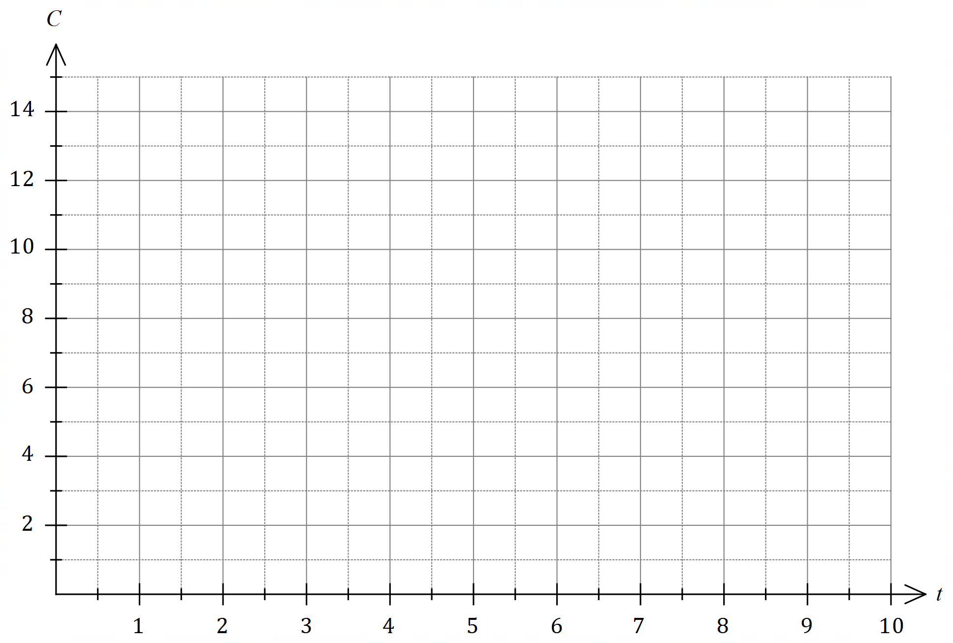

(c) Assuming that the model continues to be valid, during which year will the cost of computer memory fall below $\$1$ per gigabyte? (2 marks)

Question 11 (7 marks)
In flat rate depreciation, the value of an asset is depreciated by a fixed amount each year. Using the flat rate model, the value $V_{n}$ of a machine in dollars after $n$ years is given by $V_{n+1}=V_{n}-275$, $V_{0}=3 850$.

(a) Determine

(i) the value of the machine after $5$ years. (1 mark)

(ii) the number of years until the machine has no value. (1 mark)

Using flat rate depreciation, the value of another machine after $5$ years will be $\$2 695$ and after a further $7$ years it will become worthless. The value $T_{n}$ of this machine after $n$ years can be modelled using $T_{n}=an+b$, where $a$ and $b$ are constants.

(b) Determine the value of $a$ the value of $b$. (3 marks)

(c) Given that both machines begin to depreciate at the same time, determine the number of years until the machines have the same value and state what this value is. (2 marks)

Question 12 (8 marks)
Part of the graph of $y=f(x)$ is shown below, where $f(x)=\begin{matrix}5x \\ \overline{2x+1}\end{matrix}$.

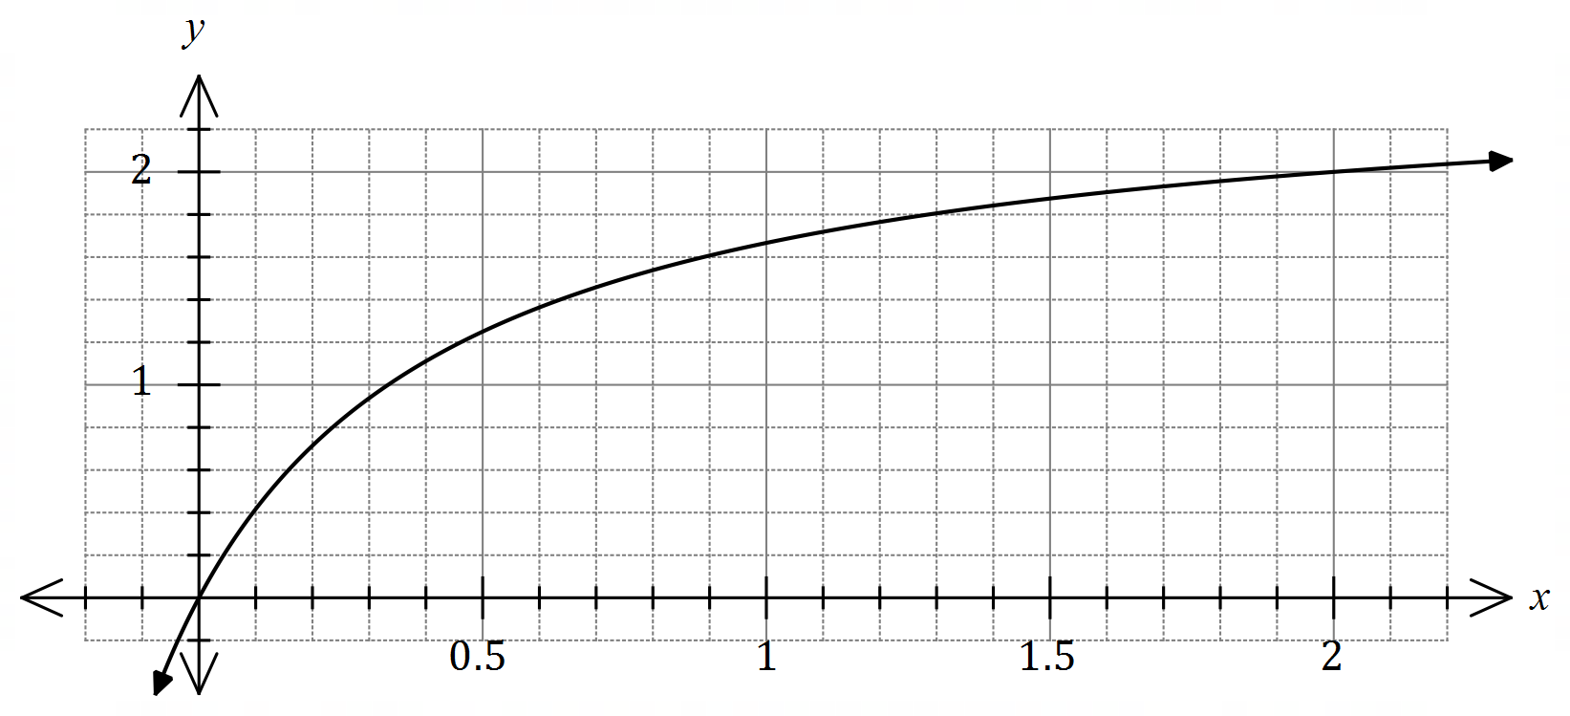

Points $A$ and $B$ lie on the curve and have $x$-coordinates of $0.5$ and $2$ respectively.

(a) Draw the chord to the curve between $A$ and $B$ on the axes above and determine the gradient of this chord. (3 marks)

Point $C$, with an $x$-coordinate of $0.5+h$, lies on the curve between $A$ and $B$. The gradient of the chord $AC$ is $m_{AC}$.

(b) Calculate $m_{AC}$ for the values of $h$ shown in the table below, recording the gradients in the table to $3$ decimal places. (3 marks)

$$h$$ | $$1$$ | $$0.5$$ | $$0.1$$ | $$0.05$$ | $$0.01$$
$$m_{AC}$$ | $$0.625$$

(c) Determine a limiting value for $m_{AC}$ as $h$ becomes very close to $0$ and state what feature of the graph of $y=f(x)$ this value represents. (2 marks)

Question 13 (7 marks)

A set of $175$ undergraduates were asked to choose their electives for the following year.
$85$ chose calculus, $58$ chose statistics and $67$ chose neither calculus nor statistics.

(a) Determine how many of the undergraduates chose both calculus and statistics. (2 marks)

(b) Determine the probability that a randomly chosen undergraduate from the set chose

(i) statistics. (1 mark)

(ii) statistics but not calculus. (1 mark)

(iii) statistics given that they chose calculus. (1 mark)

(c) Use your answers above to explain whether the choice of statistics and calculus electives is independent for these undergraduates. (2 marks)

Question 14 (6 marks)
When an alternating current is used to power a light globe, the intensity of light emitted from the globe, $I$ lumens, varies with time $t$ milliseconds and can be modelled by the formula

$$I=320+80\sin\left(\frac{πt}{10}\right).$$

(a) Draw the graph of $I$ against $t$ on the axes below for $0≤t≤60$. (3 marks)

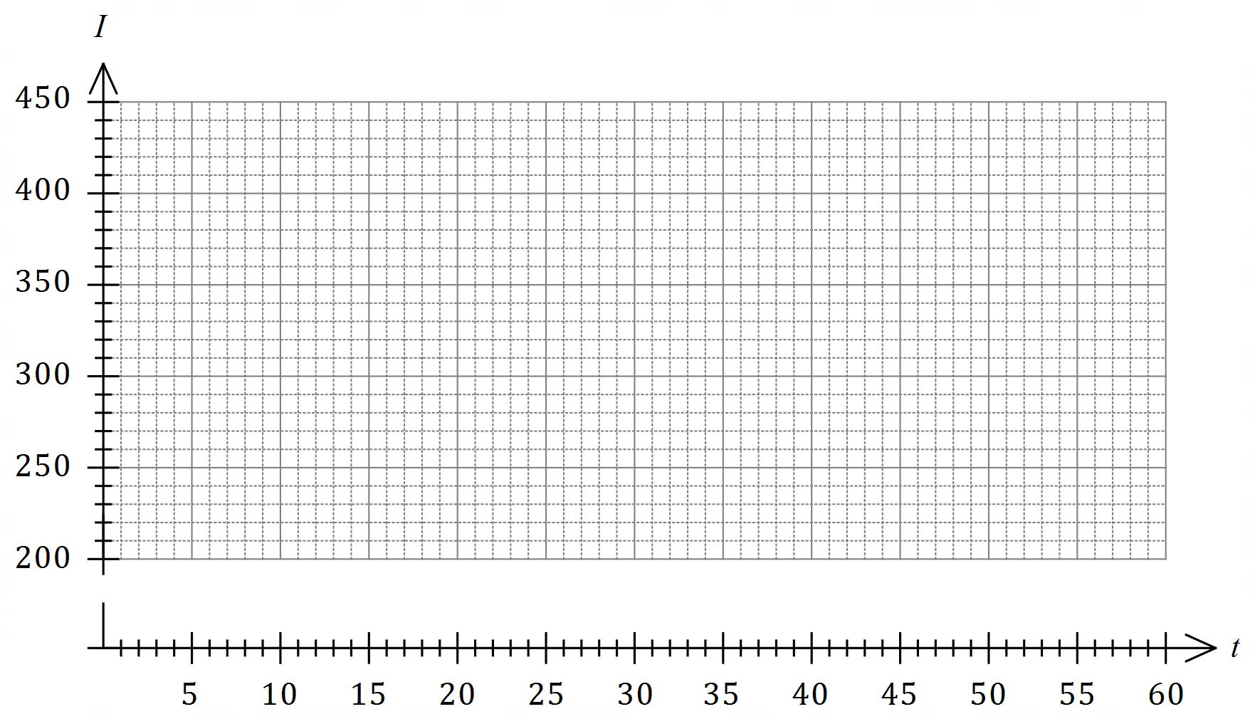

(b) State the period of $I$. (1 mark)

(c) Determine the percentage of each cycle that the intensity of light exceeds $375$ lumen.
(2 marks)

Question 15 (7 marks)
A farmer was treating a large area of land for an invasive weed. The area treated on the first day was $275$ m². Over the following months more resources were utilised so that the area treated each day was $7.5\%$ more than the previous day.

(a) Determine the area treated on the ${28}^{th}$ day. (2 marks)

The cost of the treatment was $35.8$ cents per square metre.

(b) On which day did the cost of the days treatment first exceed $\$10 000$? (2 marks)

(c) Determine, to the nearest ten dollars, the total cost of the first $15$ days of treatment.
(3 marks)

Question 16 (8 marks)
A farm grows two varieties of apples - Fuji and Gala. $42\%$ of all apples are grown in orchard $A$, $36\%$ in orchard $B$ and the remainder in orchard $C$. The proportion of Fiji apples that are grown in orchards $A, B$ and $C$ are $25\%, 30\%$ and $35\%$ respectively. After harvesting, the farm stores all the apples together in a large silo before using them to make apple juice.

(a) Determine the probability that an apple chosen at random from the silo is

(i) a Fuji grown in orchard $C$. (2 marks)

(ii) a Gala. (3 marks)

(b) Given that an apple selected at random is a Fuji, determine the probability that it was grown in orchard $A$. (3 marks)

Question 17 (13 marks)
A small body is moving in a straight line. Relative to a fixed point $O$, it has a displacement of $x$ cm at time $t$ seconds given by

$$x(t)=2t^{3}-28t^{2}+98t-72, 0≤t≤10.$$

(a) Obtain an expression for the velocity of the body in the form $v\left(t\right)=(at+b)(ct+d)$, where $a, b, c$ and $d$ are integer constants. (3 marks)

(b) Determine

(i) the initial velocity of the body. (1 mark)

(ii) the displacement of the body at the instant(s) that it is stationary. (3 marks)

(c) Use the axes below to sketch the displacement of the body over the given domain.
(3 marks)

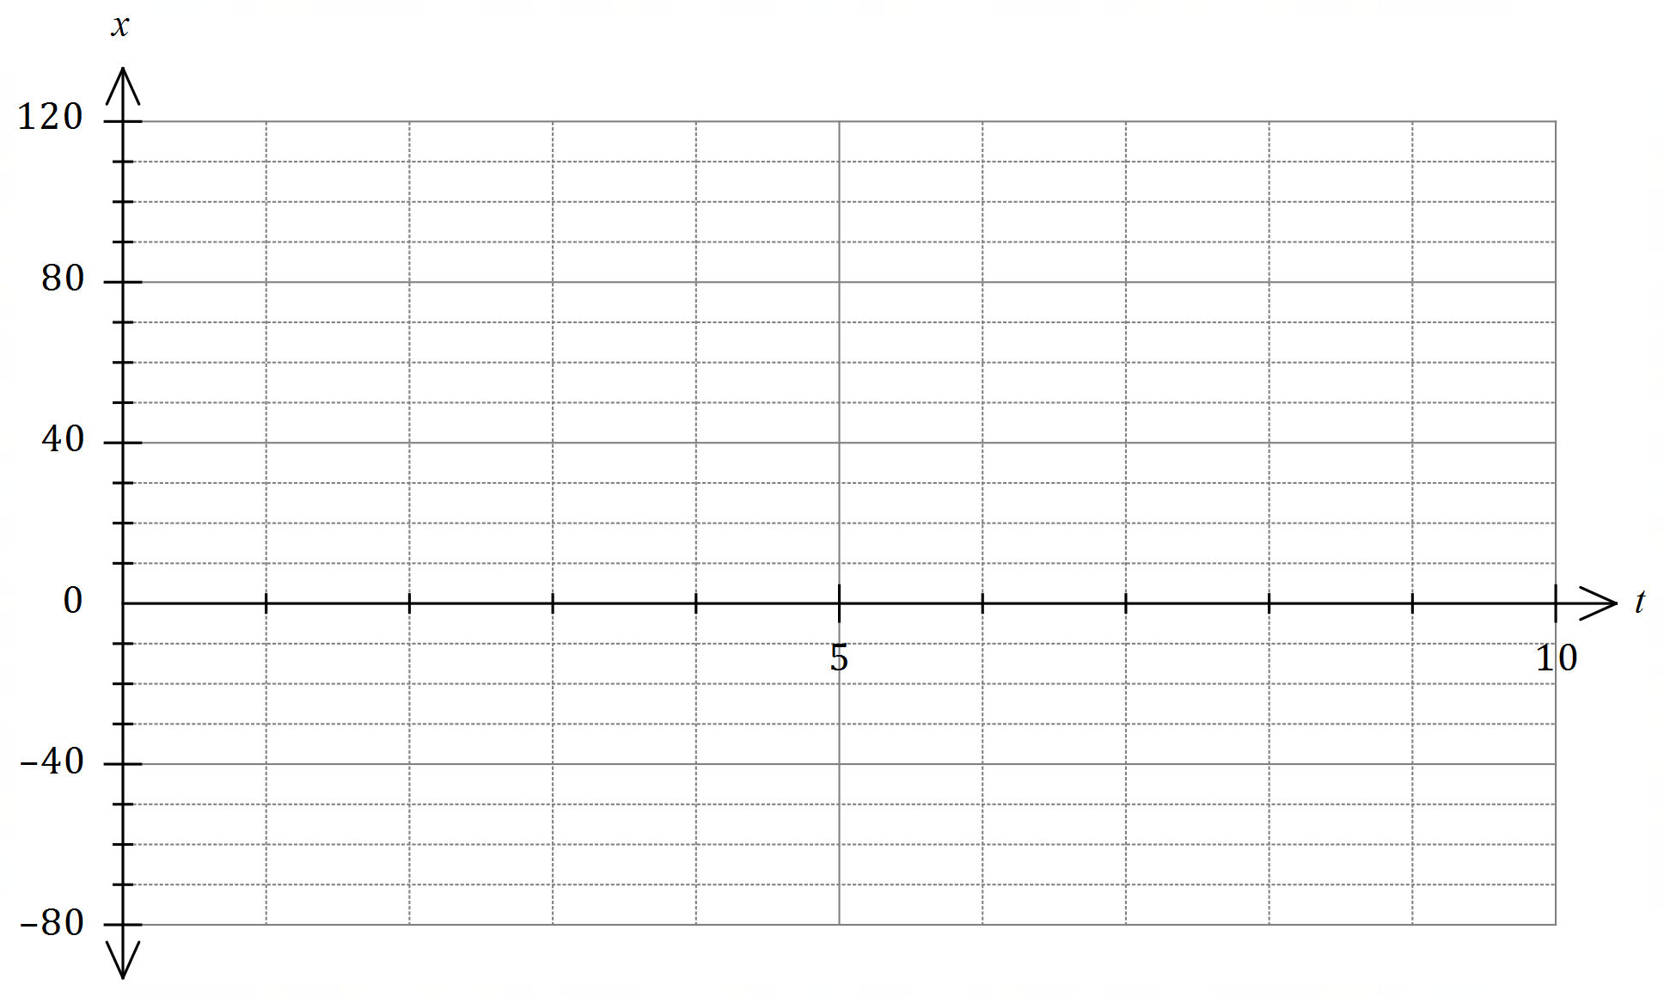

(d) State the number of times the body passed through $O$ and determine the minimum speed and maximum speed of the body as it passed through this point. (3 marks)

Question 18 (9 marks)
(a) Point $A(11, -5)$ lies on the circumference of a circle with centre $(-4, 3)$. Determine the equation of the circle. (3 marks)

(b) The graph of $y=1+\begin{matrix}a \\ \overline{x+b}\end{matrix}$ passes through the points $(1, -2)$ and $(3, 4)$.

(i) Determine the value of each of the integer constants $a$ and $b$. (3 marks)

(ii) Draw the graph of $y=1+\begin{matrix}a \\ \overline{x+b}\end{matrix}$ on the axes below, clearly indicating any asymptotes. (3 marks)

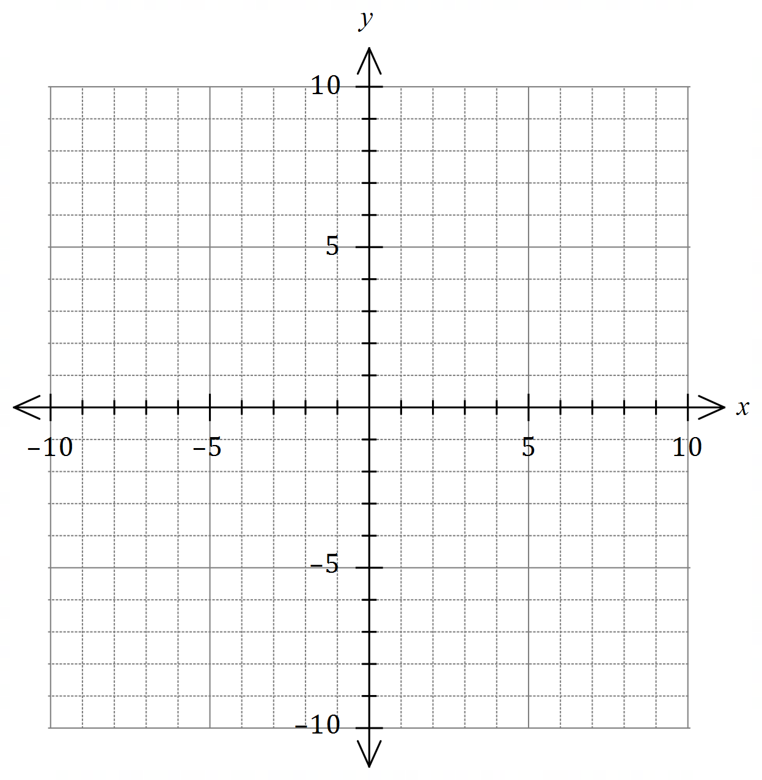

Question 19 (8 marks)
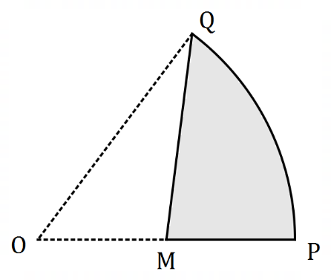
The shaded region $MPQ$ in the diagram is a
canvas awning and is part of a sector of
circle $OPQ$ with centre $O$ and radius $3.8$ m.
$QM$ is a straight line from $Q$ to $M$, the
midpoint of $OP$.
The size of $∠QOP$ is $1.1$ radians.

(a) Determine the area of sector $OPQ$. (1 mark)

(b) Determine the area of the canvas awning. (3 marks)

(c) The edge of the canvas is to be reinforced with thin wire. Determine the length of wire required. (4 marks)

Question 20 (7 marks)
A reader bought $14$ different novels, planning to read a selection of them when on holiday.

(a) Determine the number of different combinations of novels the reader could choose from if they select

(i) six novels. (1 mark)

(ii) five or six novels. (2 marks)

Four of the $14$ different novels are by the author Harper.

(b) The reader makes a random selection of six novels. Determine the probability that

(i) none of the novels selected are by Harper. (2 marks)

(ii) one of the novels selected is by Harper. (2 marks)

Question 21 (7 marks)
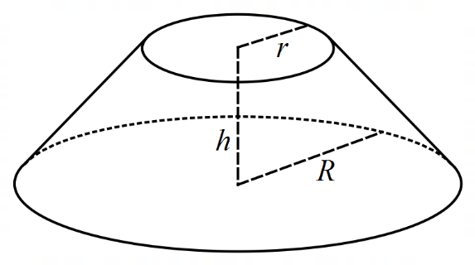
The frustum shown at right is a truncated right cone.

The volume of such a solid is $V=\begin{matrix}πh \\ \overline{ 3 }\end{matrix}(r^{2}+R^{2}+rR)$,
where $r$ is the radius of the smaller circle, $R$ is the
radius of the larger circle and $h$ is the perpendicular
distance between the two parallel circles.

Consider frustum $F$ where $r=x$ cm,
$R=3r$ and $r+h=36$ cm.

(a) Show that the volume of frustum $F$ is $156πx^{2}-\begin{matrix}13πx^{3} \\ \overline{ 3 }\end{matrix}$ cm³. (3 marks)

(b) Use a calculus method to determine the value of $x$ that maximises the volume of frustum $F$ and state this maximum volume, rounding your answer to the nearest cm³. (4 marks)

Supplementary page

Question number: _________

© 2020 WA Exam Papers. Melville Senior High School has a non-exclusive licence to copy and communicate this document for non-commercial, educational use within the school. No other copying, communication or use is permitted without the express written permission of WA Exam Papers. SN063-162-2.

